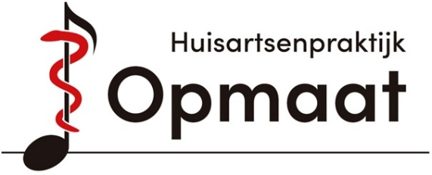
Newsletter
October 2025
Our Team
There are a number of new faces in the practice. They would like to briefly introduce themselves to you.

Doctor’s Assistant
My name is Rania, I am 26 years old and live in Almere. I started my training as a medical assistant on September 1st 2025. I am following the BBL-variant, which means that I go to school one day a week for both theory and practice. On the other days, I work at De Opmaat as an ‘intern’, where I continue my training in practice. I am really enjoying it.

Pharmacist-Therapist
My name is Aya Al-Rashed, and I am a pharmacist-therapist. I have been working at De Opmaat Since February 2025. I collaborate with the general practitioners to provide you with the best medication care.


When can you see me? For example, if you have questions about the effectiveness and side effects of medications.
You can make an appointment with me through the medical assistant or be referred by the general practitioner.
I am available on Tuesdays and (on odd weeks) Wednesdays.

Receptionist
Hello, my name is Nathalie, I am married and have two children. A daughter who is almost 20 and a son who is 14 years old. I have lived here in Muziekwijk for almost 25 years, so for some of you, I may be a familiar face. I hope I can help you with any questions you may have at the reception.

Physician Assistant (PA) in Training
My name is Lisa Nijhuis, and I recently started working in the practice as a Physician Assistant (PA) in training. Before this, I worked as a nurse and gained experience in various settings. A PA is a medical professional who is trained to take over certain medical tasks from a physiciant. During my 2.5-year training, I combine studying with working in the practice, allowing me to continuously expand my knowledge and experience. In practice, it may happen that, in consultation with the medical assistant, you are offered an appointment with me. This is, of course, in close collaboration with your general practitioner.
I look forward to meeting you in the practice soon.

General Practitioners
As of November 1st, Dr. Kooistra will be on maternity leave. Her practice will be taken over by Dr. Zonneveld. Her working days are Tuesday, Wednesday, and Friday.

Information
Reception
The reception is open every day from 8:00 AM to 12:30 PM. In the afternoon, it is open for emergencies only.

You can visit the reception to collect referral letters, drop off urine samples, update your address, or ask other questions. Please note that Nathalie is not a medical assistant, so it is not possible to make an appointment at the reception.

Appointments

You can call between 8:00 AM and 10:00 AM to make an appointment. We try to offer you an appointment on the same day that you call, preferably with your own general practitioner. It’s best to call on the day that your doctor works.

Mondays are particularly busy, so for questions that can wait, please call on another day.

Flu Vaccination
On Tuesday, October 28th, and Wednesday October 29th, both in the afternoon, the flu vaccination will be administered at the practice. The time schedule is from 14.30 to 18.00.
If you are eligible for this, you have received an invitation.

On Monday, October 27th, the flu vaccination will be given at the Mozartplantsoen.

If you are unable to come to the practice, you can contact the medical assistants for a flu shot at home.
If you have not received an invitation but you are eligible, please call the medical assistants.

If you are not eligible but still wish to receive the flu vaccination, please contact the practice. A prescription will be made by the general practitioner. You can collect and pay for the medication at the pharmacy. For the vaccination, you can make an appointment with the medical assistants. This consultation must also be paid at the reception. The cost for the flu shot administered by us is €32.

Pneumococcal Vaccination
The pneumococcal vaccine protects you against diseases caused by pneumococci, for instance pneumonia. The vaccine is long-lasting and can prevent severe illness, hospitalization, and death.

This autumn, the following groups will receive an invitation for the pneumococcal vaccination:
Born in 1965 (who are turning 60 this year).
Born in 1947 or earlier (who are turning 78 years old or older this year).

Smoking Cessation
Did you know that you can quit smoking with professional guidance? This is fully covered by your basic health insurance, including any necessary aids. We use a step-by-step quitting plan and the book Heel Nederland Stopt (The Whole of the Netherlands Stops).
If you're motivated to quit smoking, we’d love to help.
Astrid and Tryntsje

